- Overview

Price Audit activity can be also described as Store Initiated price changes. This data is stored within the table item_audit.

- Login Process

The login process should be the same as for User Administration.

- The “Price Audit Admin” Window

After the supervisor successfully logs in, the program should display the “Price Audit Admin” Window. This contains a list of all the active Store Initiated (SI) price changes.

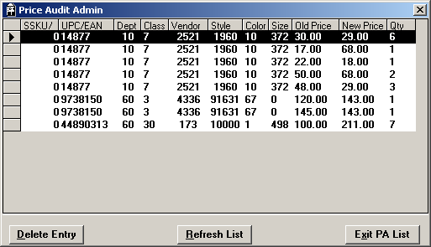

Note: The new application should join the two SKU components into a single column (see database details).

  - Database Details

select
(sku_overflow * 100000000) + sku ssku,
dept,
class,
vendor,
style,
color,
size,
old_rtl,
new_rtl,
mrkd_qty,
sku_overflow, (not displayed)
sku (not displayed)
from item_audit
where status = “A”
order by dept, class, vendor, style, color, size, ssku;

- The “Delete Entry” Button

When the user presses the “Delete Entry” button, the program should confirm by asking the question “Delete Current Row. Are You Sure?” If the user clicks “No”, no action should be taken.

If, however, the user clicks “Yes”, the program should delete the row and redraw the Price Admin screen with the current data.

  - Database Details

delete from item_audit
where sku_overflow = <selected SKU overflow>
and sku = <selected SKU>
and dept = <selected dept>
and class = <selected class>
and vendor = <selected vendor>
and style = <selected style>
and color = <selected color>
and size = <selected size>
and old_rtl = <selected “old price”>
and new_rtl = <selected “new price”>;

- The “Refresh List” Button

When the user presses the “Refresh List” button, the program should redraw the Price Admin screen with the current data.

